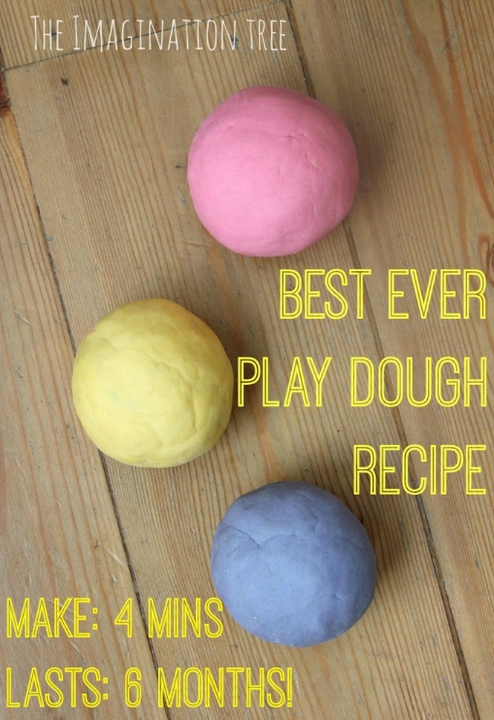

Best Ever No-Cook Play Dough Recipe
You need:
2 cups plain flour (all purpose)
2 tablespoons vegetable oil (baby oil and coconut oil work too)
1/2 cup salt
2 tablespoons cream of tartar
1 to 1.5 cups boiling water (adding in increments until it feels just right)
gel food colouring (optional)
few drops glycerine (my secret ingredient for stretch and shine!)
Method:
Mix the flour, salt, cream of tartar and oil in a large mixing bowl
Add food colouring TO the boiling water then into the dry ingredients
Stir continuously until it becomes a sticky, combined dough
Add the glycerine (optional)
Allow it to cool down then take it out of the bowl and knead it vigorously for a couple of minutes until all of the stickiness has gone. * This is the most important part of the process, so keep at it until it’s the perfect consistency!
If it remains a little sticky, then add a touch more flour until just right

